Group_Subquery

1) Display the first name of all the candidates who are Democrats. (use subquery)
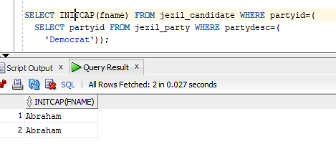
2) Display the party description of the all the candidates whose last name ends with ‘C’ regardless of case. (Use subquery)
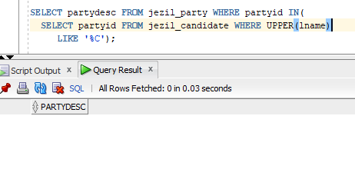

3) Display the first name of all the candidates who are either Democrats or Republicans regardless of case. (use subquery, use in clause)
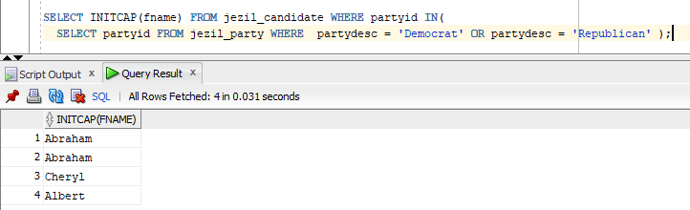

4) Create a second table called candidate2 that contains all the data from the candidate table using create table as… statement. The new table should contain only the first name, lastname and the salary, lowered by 10% for all the candidates who are Republicans
